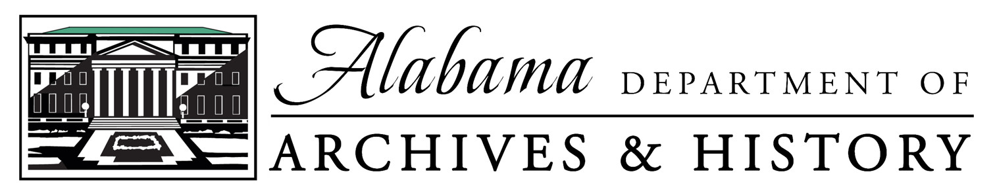

Position: 30451 (003) Collections Curator – General

Annual Salary Range: $35,457.60 - $53,707.20

Deadline for applications: July 20, 2022

Anticipated start date: September 1, 2022

The Alabama Department of Archives and History (ADAH) seeks a collections curator with experience working with general museum collections. Primary duties include cataloging, researching, documenting, and inventorying objects held by the ADAH Museum Division according to professional standards and best practices. The curator will participate in committees to assist with the creation and implementation of departmental decisions, policies, and procedures and will contribute to special projects such as exhibits and community outreach. As a member of the Museum Collections Section, the curator reports to the Section Coordinator.

Essential Job Duties:
- Create object catalog records in PastPerfect museum software, including determining standard object name nomenclatures, recording detailed artifact descriptions, researching provenance data, evaluating the physical condition of artifacts, and capturing digital images of objects.
- Work with staff members, government agencies, and private citizens to acquire historical collections that fit the parameters of ADAH collecting.
- Monitor environmental conditions of artifact processing and storage rooms to promote long-term preservation of the collection.
- Participate in planning and implementing conservation treatments for objects in the permanent collection.
- Provide reference assistance to researchers regarding artifacts in the ADAH collection and respond to loan requests.
- Work closely with staff members in creating and installing exhibits and developing related public programs.
- Promote agency collections and programs through presentations and other outreach activities.

This position will require occasional weekend and after-hours work and some travel, mostly in-state.
Preferred Knowledge, Skills, and Abilities:
- Knowledge of standard museum policies and procedures.
- Knowledge of research tools and techniques for the documentation of historic objects.
- Knowledge of current issues and trends in collections management and ability to keep up to date with new practices and techniques.
- Knowledge of history and philosophy of museums.
- Familiarity with photography and/or 3D scanning of collections for documentation purposes.
- Familiarity with PastPerfect or other museum cataloging software.
- Commitment to the museum profession by memberships and participation in professional associations.
- Commitment to ongoing professional development and contribution.
- Ability to work well with a diverse population.
- Ability to express ideas clearly, both orally and in writing.
- Ability to work independently and perform effectively in a collaborative environment.
- Ability to lift and carry heavy boxes weighing on average 50 pounds.

Minimum Qualifications:
- Bachelor’s degree from an accredited four-year college or university in museum studies, public history, history, anthropology, archaeology, American studies, or a closely related field.
- One year of curatorial work experience in a museum or historic site working with artifact collections.
- A valid driver’s license.

Additional education in a required field of study beyond the minimum listed above and which included a museum internship or practicum may be substituted for the required work experience.

Founded in 1901, the Alabama Department of Archives and History is the state’s government-records repository, a special-collections library and research facility, and home to the Museum of Alabama, the state history museum. To learn more about the agency, visit http://www.encyclopediaofalabama.org/article/h-2014

In June 2020, the agency issued a Statement of Recommitment to inclusive history: https://bit.ly/ADAH_StatementOfRecommitment

Application Procedure:
1. Apply to the State Personnel Department:
- Find the official position announcement at: https://www.personnel.alabama.gov/Jobs
- Complete the State of Alabama Application available at:
https://personnel.alabama.gov/Downloads/StateApp.pdf
or create a profile and apply online at: https://www.personnel.alabama.gov/Services/login?LI=OES
- Application process questions may be answered at: https://www.personnel.alabama.gov/Process or https://www.personnel.alabama.gov/Services/Downloads/OESHelpDoc.pdf
- Submit the application to State Personnel and include transcripts.

2. After applying to the State Personnel Department, submit the following documents via email to ryan.blocker@archives.alabama.gov:
- Cover letter (including availability details)
- Resume
- Academic transcripts (may be unofficial)
- Copy of application submitted to the State Personnel Department
- List of professional references including contact information.

The deadline to apply is July 20, 2022. Candidates will be selected for interview based on the information submitted. The anticipated hiring date is on or before September 1, 2022.

Ms. Ryan Blocker
ryan.blocker@archives.alabama.gov
Museum Collections Coordinator
Alabama Department of Archives and History
P.O. Box 300100
Montgomery, AL 36130-0100
334-353-4696

